Contents

SSH Set up 2

User Groups 6

Folders and Permissions 7

Research Documents 12

# SSH Set up

Add known host to knownhosts file for albert

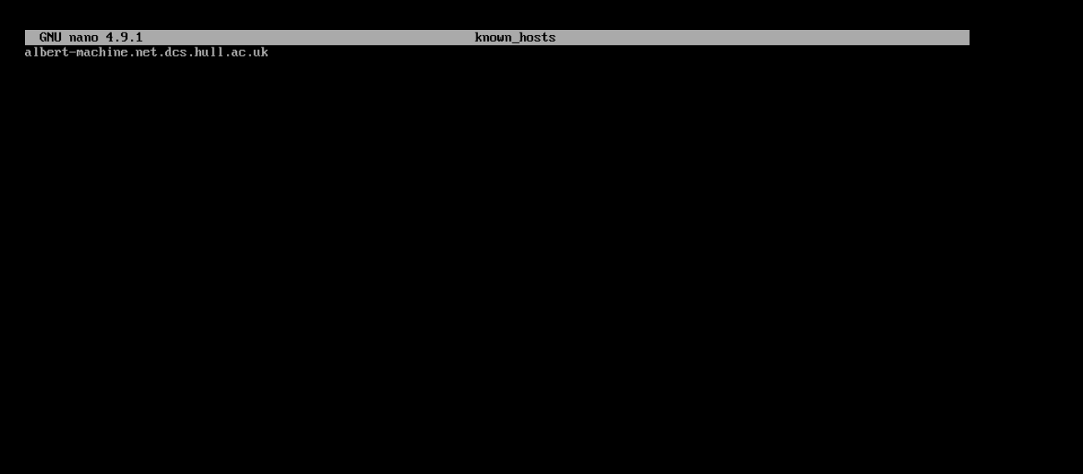

Change Sshd_config to allow host authentication

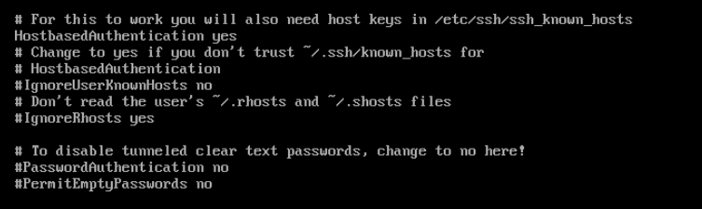

# User Groups

John Murray : Staff Group

Steve Smith : ThirdYear Group

Laura Lance: Marketing Group

Annika, Albert: PHD Group

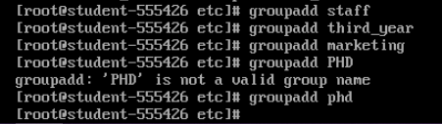

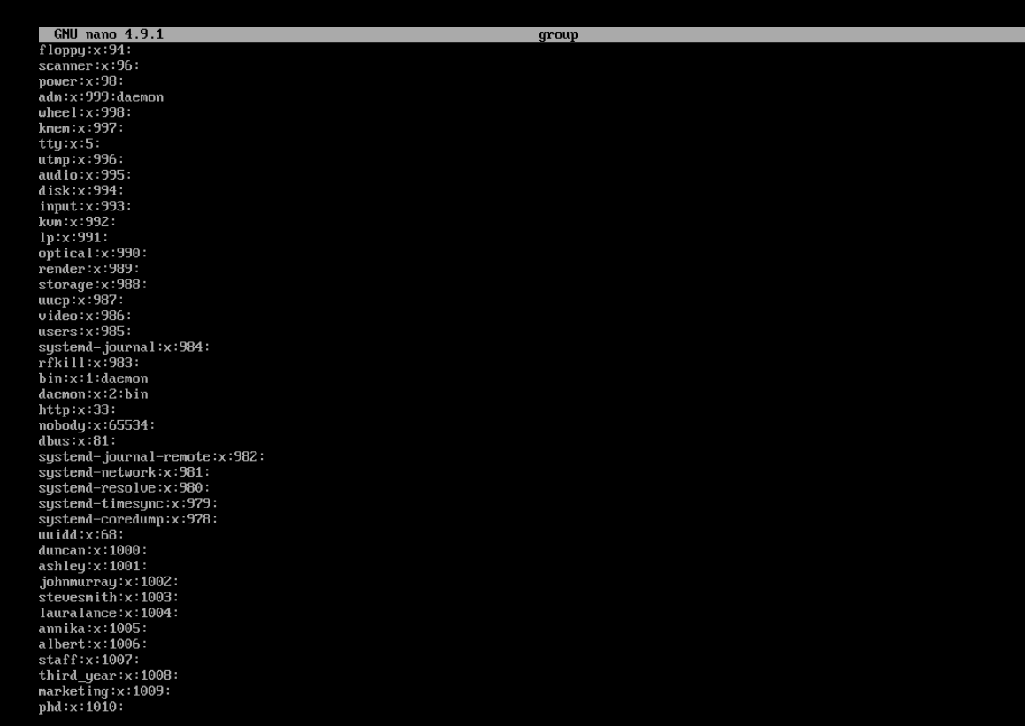



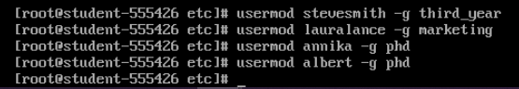

# Folders and Permissions

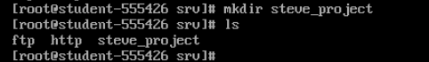

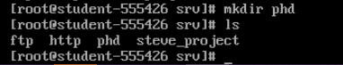

Folder owners

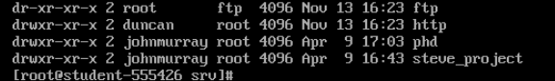

Set permissions for folders

http owner = root

http Group access = Marketing

Everyone Else (No access)

Octal for http

RWX, RWX,___

421, 420 000

770

Steves folder owner = John

Steves group access = ThirdYear

Octal for Steves Folder

RWX,R__,___

421 4_1,___

750

PHD folder

PHD Folder owner = John

PHD Folder Group Access = PHD

Octal for PHD Folder

RWX, R_X,___

750

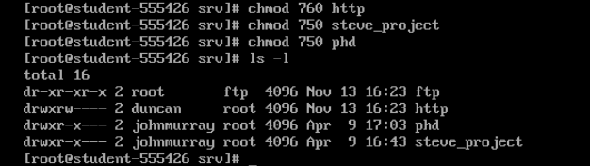

Change group owner

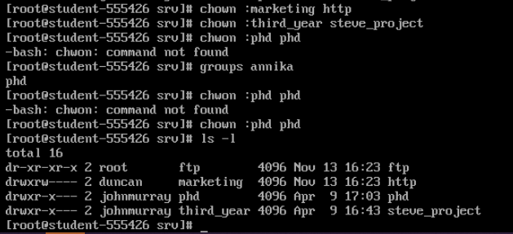

Annika Tests

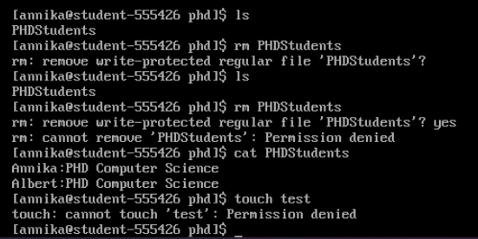

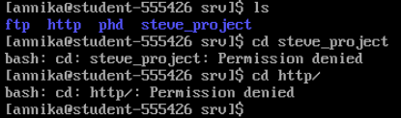

Steve Tests

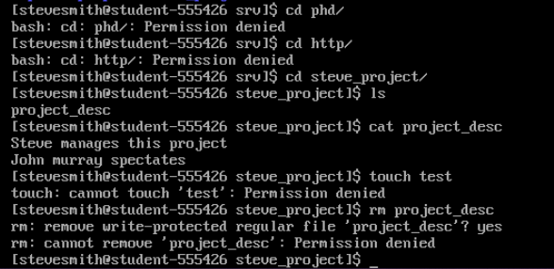

Laura lance tests

Could not access http

Gave execute permissions to group

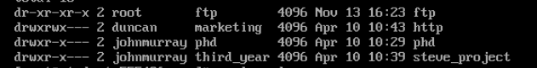

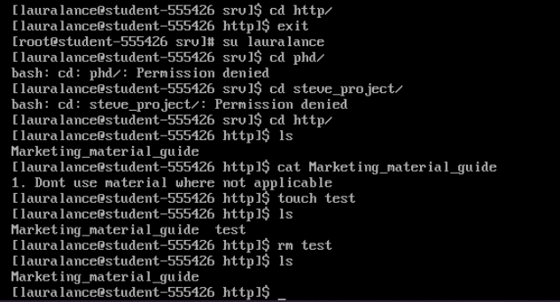

John tests

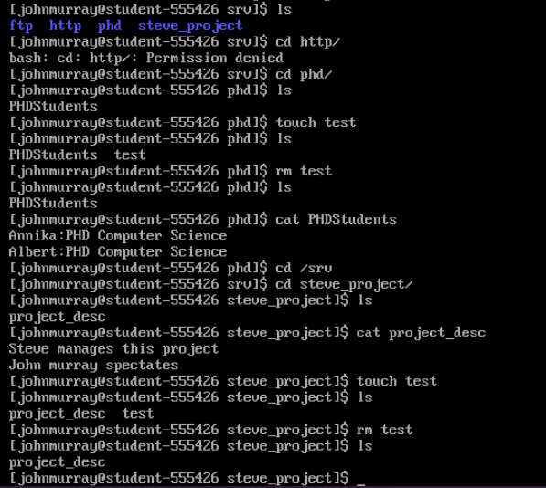

# Research Documents

